Digital Logic Design

QUIZ#4

Section N

Roll#-------------------------------

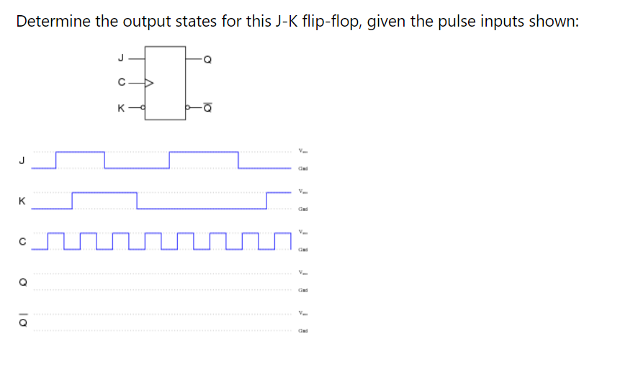

**Solution:**

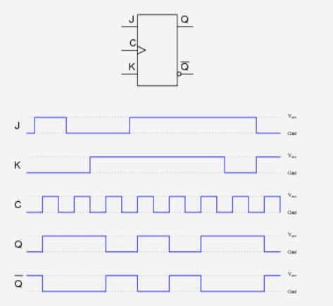

Q2. (5 Marks)

1. Make a Characteristic Table and write down characteristic equation for JK Flip Flop. (2)
2. Make JK flip flop using D Flip Flop? (3)

Solution:

a) given in slides also covered in class

b) given in slides

